**Normal user and guest**

**User login**

|  |  |  |  |  |
| --- | --- | --- | --- | --- |
| **url** | **method** | **parameter** | **value** | **note** |
| /api/login/ | post | email | Your email address |  |
|  |  | password | Your pass |  |

done

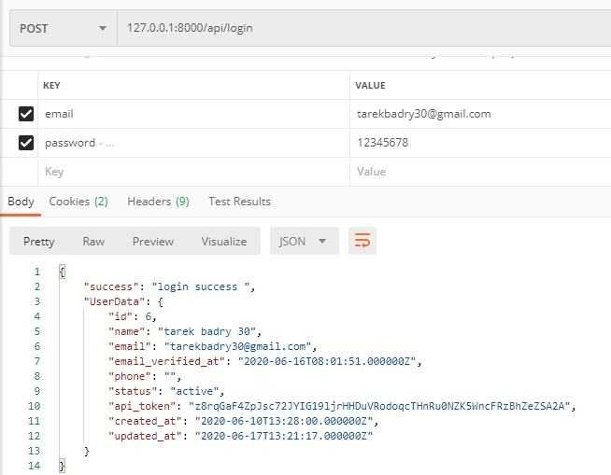

**User register**

|  |  |  |  |  |
| --- | --- | --- | --- | --- |
| **url** | **method** | **parameter** | **value** | **note** |
| /api/register/ | post | email | Your email address |  |
|  |  | password | Your pass |  |
|  |  | name |  |  |
|  |  | phone |  |  |

done

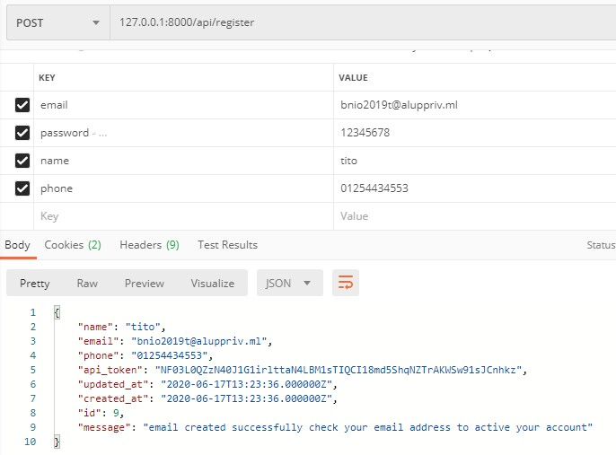

**User resend password reset link**

|  |  |  |  |  |
| --- | --- | --- | --- | --- |
| **url** | **method** | **parameter** | **value** | **note** |
| /api/forgotPassword/ | post | email | Your email address |  |

done

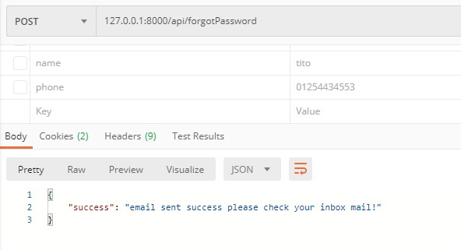

**User resend email activation link**

|  |  |  |  |  |
| --- | --- | --- | --- | --- |
| **url** | **method** | **parameter** | **value** | **note** |
| /api/resendEmailActivation/ | get | email | Your email address |  |

done

**User home page**

|  |  |  |  |  |
| --- | --- | --- | --- | --- |
| **url** | **method** | **Parameter** | **value** | **note** |
| /api/home/ | get | page | 2 | Optional for more data |

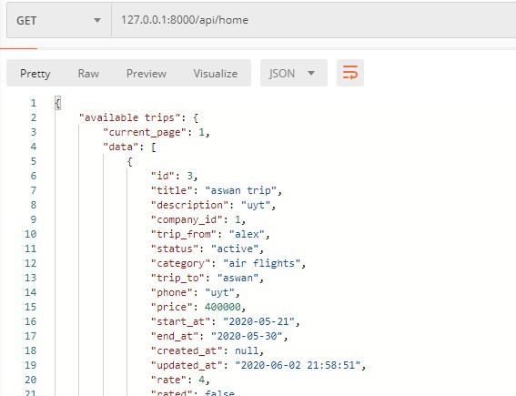

done

**trip details page**

|  |  |  |  |  |
| --- | --- | --- | --- | --- |
| **url** | **method** | **parameter** | **value** | **note** |
| /api/trip_details/ | post | trip_id | Id of the trip |  |

done

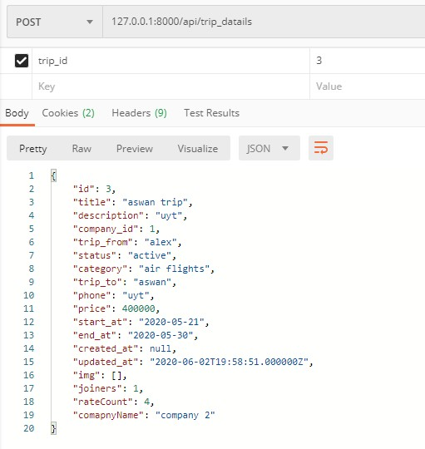

**Check voucher of trip page**

|  |  |  |  |  |
| --- | --- | --- | --- | --- |
| **url** | **method** | **parameter** | **value** | **note** |
| /api/voucher/check | post | trip_id | Id of the trip |  |
|  |  | code | xxxx-xxxx-xxxx-xxxx | Code of voucher |

done

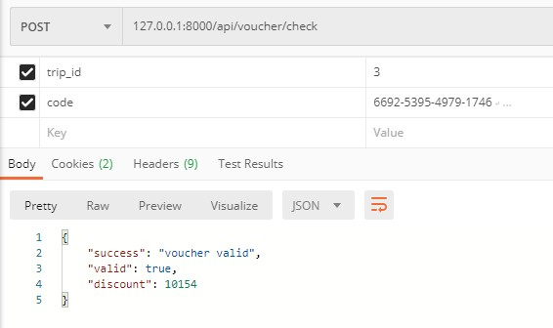

**Join trip page**

|  |  |  |  |  |
| --- | --- | --- | --- | --- |
| **url** | **method** | **parameter** | **value** | **note** |
| /api/join/ | post | trip_id | Id of the trip |  |
|  |  | api_token |  |  |
|  |  | code | Voucher code | Optional if available |

Not completed

**Cancel trip page**

|  |  |  |  |  |
| --- | --- | --- | --- | --- |
| **url** | **method** | **parameter** | **value** | **note** |
| /api/cancel/ | post | trip_id | Id of the trip |  |
|  |  | api_token |  |  |

Not completed

**search page**

|  |  |  |  |  |
| --- | --- | --- | --- | --- |
| **url** | **method** | **parameter** | **value** | **note** |
| /api/search/ | get | city | Name of city | optional |
|  |  | date | Start date of trip | Optional  [yyyy-mm-dd] |
|  |  | category | One of [air flights ,sea trips ,land trips] | Optional |
|  |  | page | 2 | Optional for more data |
|  |  | text | Any text you want to search for |  |

done

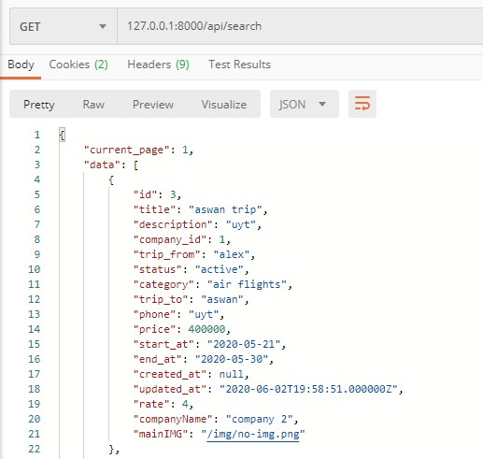

**Edit user profile page**

|  |  |  |  |  |
| --- | --- | --- | --- | --- |
| **url** | **method** | **parameter** | **value** | **note** |
| /api/edit-profile/ | post | Api_token |  |  |

done

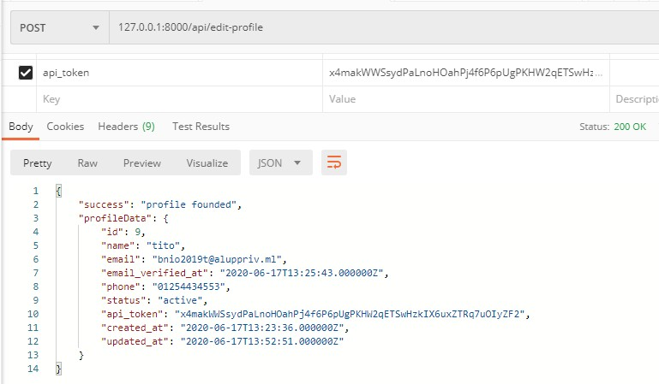

**update profile page**

|  |  |  |  |  |
| --- | --- | --- | --- | --- |
| **url** | **method** | **parameter** | **value** | **note** |
| /api/update-profile | post | Api_token |  |  |
|  |  | name | Your name |  |
|  |  | email | Your email |  |
|  |  | current_password | Your current password |  |
|  |  | new_password | Your New password | Optional |
|  |  | new_password_confirmation |  | Required if new password set |

done

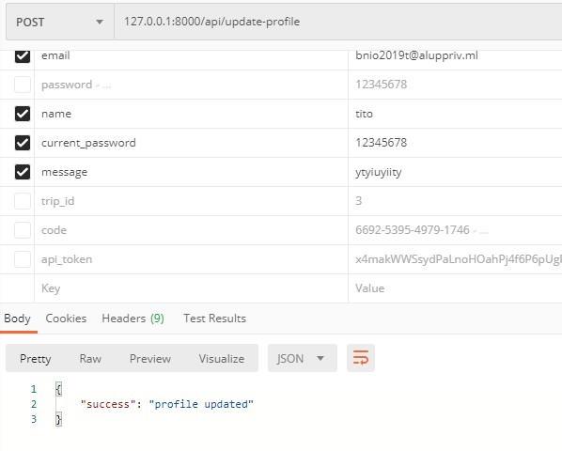

**partners**

**partner login**

|  |  |  |  |  |
| --- | --- | --- | --- | --- |
| **url** | **method** | **parameter** | **value** | **note** |
| /api/company/login | post | email | Your email address |  |
|  |  | password | Your pass |  |

done

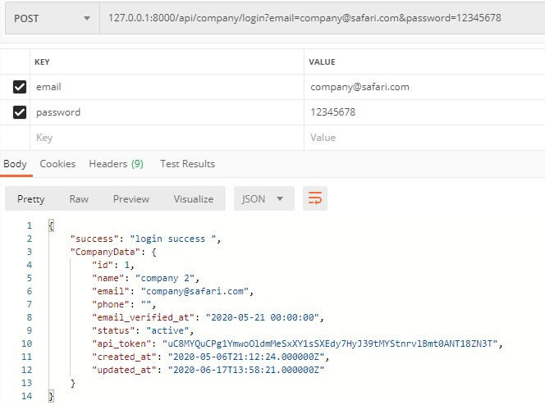

**partner register**

|  |  |  |  |  |
| --- | --- | --- | --- | --- |
| **url** | **method** | **parameter** | **value** | **note** |
| /api/company/register | post | email | Your email address |  |
|  |  | password | Your pass |  |
|  |  | name |  |  |
|  |  | Phone |  |  |

done

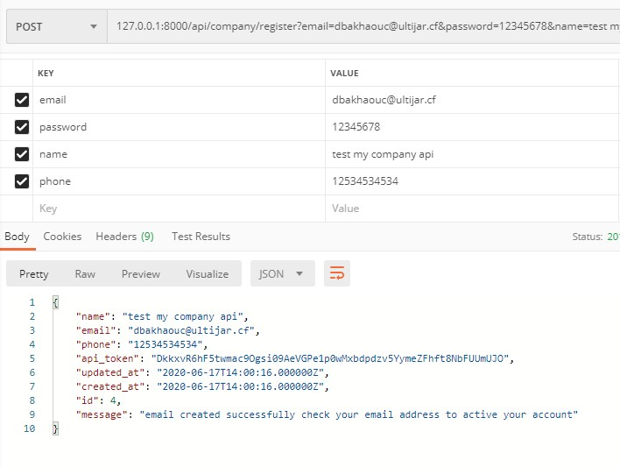

**partner resend password reset link**

|  |  |  |  |  |
| --- | --- | --- | --- | --- |
| **url** | **method** | **parameter** | **value** | **note** |
| /api/forgotPassword | post | email | Your email address |  |

done

**partner resend email activation link**

|  |  |  |  |  |
| --- | --- | --- | --- | --- |
| **url** | **method** | **parameter** | **value** | **note** |
| /api/resendEmailActivation | post | email | Your email address |  |

done

**partner home page**

|  |  |  |  |  |
| --- | --- | --- | --- | --- |
| **url** | **method** | **parameter** | **value** | **note** |
| /api/company/my_trips | post | api_token |  |  |

done

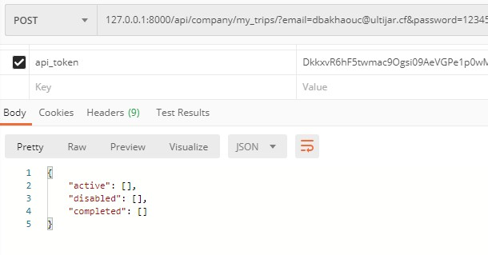

**partner trip details page**

|  |  |  |  |  |
| --- | --- | --- | --- | --- |
| **url** | **method** | **parameter** | **value** | **note** |
| /api/company/trips/trip_details/ | post | api_token |  |  |
|  |  | trip_id | Id of the trip |  |

done

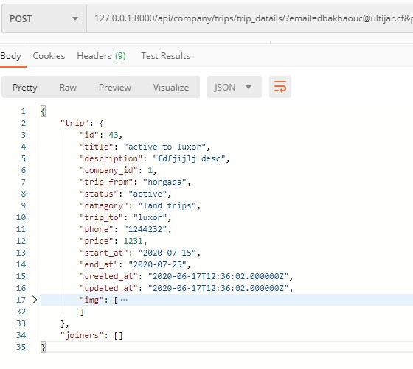

**trip status control page**

|  |  |  |  |  |
| --- | --- | --- | --- | --- |
| **url** | **method** | **parameter** | **value** | **note** |
| /api/company/trips/control/ | post | api_token |  |  |
|  |  | trip_id | Id of the trip |  |
|  |  | action | One of [active,disabled,completed] |  |

done

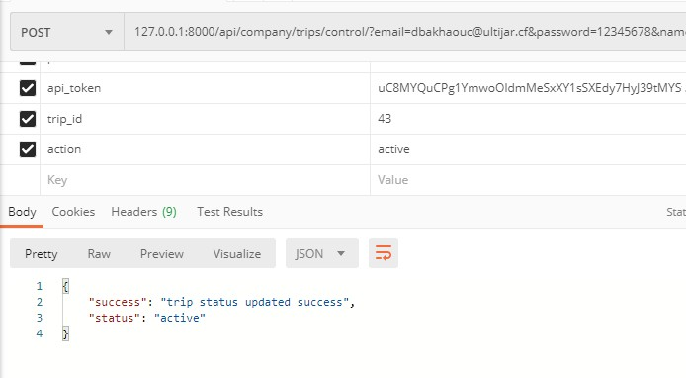

**Create trip page**

|  |  |  |  |  |
| --- | --- | --- | --- | --- |
| **url** | **method** | **parameter** | **value** | **note** |
| /api/company/trips/create/ | post | api_token |  |  |
|  |  | title | Trip title |  |
|  |  | description |  |  |
|  |  | trip_from | Start trip from |  |
|  |  | trip_to | Trip destination |  |
|  |  | phone |  |  |
|  |  | price |  |  |
|  |  | category | One of [air flights ,sea trips ,land trips] |  |
|  |  | strart_at | Date of trip start |  |
|  |  | end_at | Date of trip end |  |
|  |  | Img[] | Image must be one at least |  |

done

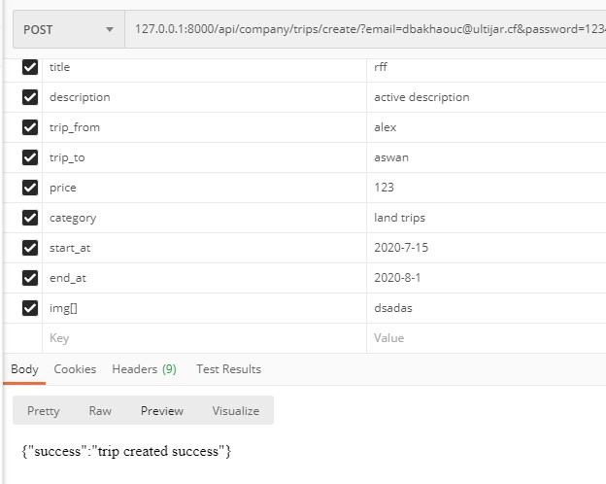

**Create New voucher of trip page**

|  |  |  |  |  |
| --- | --- | --- | --- | --- |
| **url** | **method** | **parameter** | **value** | **note** |
| /api/company/new-voucher | post | Api_token |  |  |
|  |  | discount | 1 <= discount <= 99 | Discount percent |
|  |  | trip_id |  |  |
|  |  | expire_at | yyyy-mm-dd | The date of expiring voucher code |

done

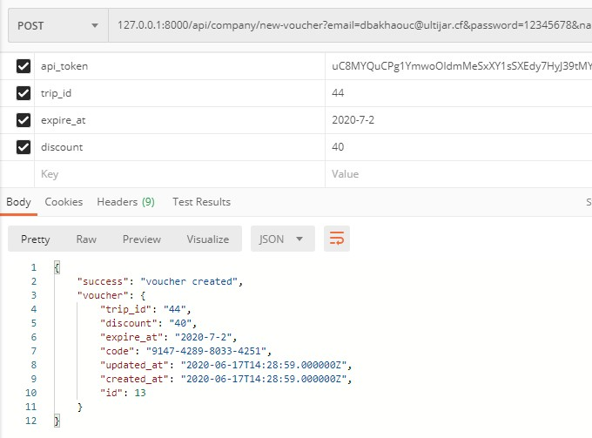

**Check join users code page**

|  |  |  |  |  |
| --- | --- | --- | --- | --- |
| **url** | **method** | **parameter** | **value** | **note** |
| /api/company/check-QR-code/ | post | Api_token |  |  |
|  |  | QR_code | xxxx-xxxx-xxxx-xxxx | The decode of QR code of joiner |
|  |  | trip_id |  |  |

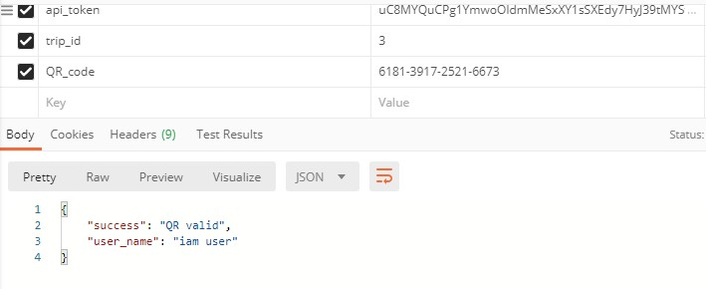

**Edit partner profile page**

|  |  |  |  |  |
| --- | --- | --- | --- | --- |
| **url** | **method** | **parameter** | **value** | **note** |
| /api/company/edit-profile/ | post | Api_token |  |  |

done

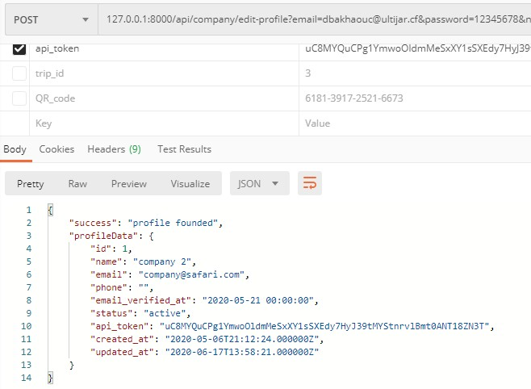

**Update partner profile page**

|  |  |  |  |  |
| --- | --- | --- | --- | --- |
| **url** | **method** | **parameter** | **value** | **note** |
| /api/company /update-profile/ | post | Api_token |  | Required |
|  |  | name | Your name | Required |
|  |  | email | Your current email | Required |
|  |  | current_password | Your current password | Required |
|  |  | new_password | Your New password | Optional |
|  |  | new_email | New email to change | optional |
|  |  | new_password_confirmation |  | Required when new password set |

done

**admin users**

**admin login**

|  |  |  |  |  |
| --- | --- | --- | --- | --- |
| **url** | **method** | **parameter** | **value** | **note** |
| /api/admin/login/ | post | email | Your email address |  |
|  |  | password | Your pass |  |

done

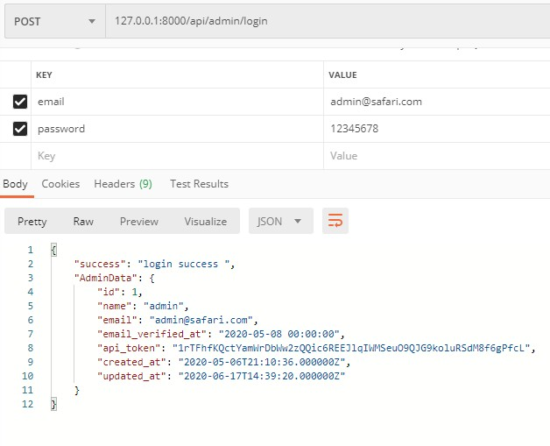

**admin resend password reset link**

|  |  |  |  |  |
| --- | --- | --- | --- | --- |
| **url** | **method** | **parameter** | **value** | **note** |
| /api/admin/forgotPassword/ | post | email | Your email address |  |
|  |  |  |  |  |

**done**

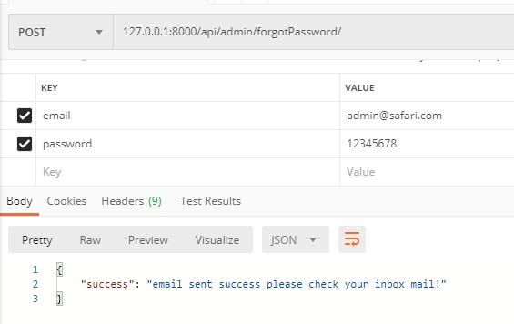

**admin home page**

|  |  |  |  |  |
| --- | --- | --- | --- | --- |
| **url** | **method** | **parameter** | **value** | **note** |
| /api/admin/home/ |  | api_token |  |  |

done

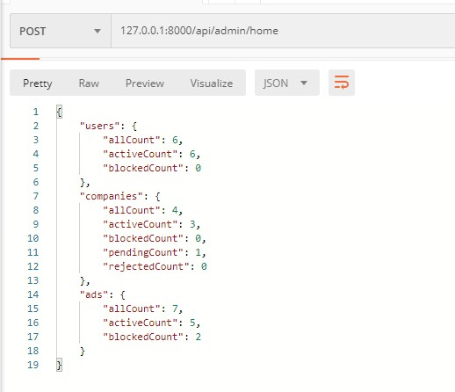

**admin all parnters page**

|  |  |  |  |  |
| --- | --- | --- | --- | --- |
| **url** | **method** | **parameter** | **value** | **note** |
| /api/admin/partners/ |  | api_token |  |  |

done

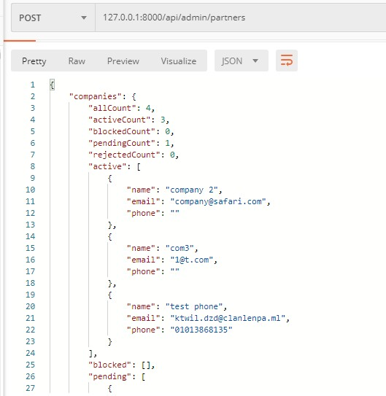

**admin accept parnters page**

|  |  |  |  |  |
| --- | --- | --- | --- | --- |
| **url** | **method** | **parameter** | **value** | **note** |
| /api/admin/partner/accept |  | api_token |  |  |
|  |  | company_id |  |  |

done

**admin reject parnters page**

|  |  |  |  |  |
| --- | --- | --- | --- | --- |
| **url** | **method** | **parameter** | **value** | **note** |
| /api/admin/partner/reject |  | api_token |  |  |
|  |  | company_id |  |  |

done

**admin block parnters page**

|  |  |  |  |  |
| --- | --- | --- | --- | --- |
| **url** | **method** | **parameter** | **value** | **note** |
| /api/admin/partner/block |  | api_token |  |  |
|  |  | company_id |  |  |

done

**admin active parnters page**

|  |  |  |  |  |
| --- | --- | --- | --- | --- |
| **url** | **method** | **parameter** | **value** | **note** |
| /api/admin/partner/reject |  | api_token |  |  |
|  |  | company_id |  |  |

done

**Edit Admin profile page**

|  |  |  |  |  |
| --- | --- | --- | --- | --- |
| **url** | **method** | **parameter** | **value** | **note** |
| /api/admin/edit-profile/ | post | Api_token |  |  |

done

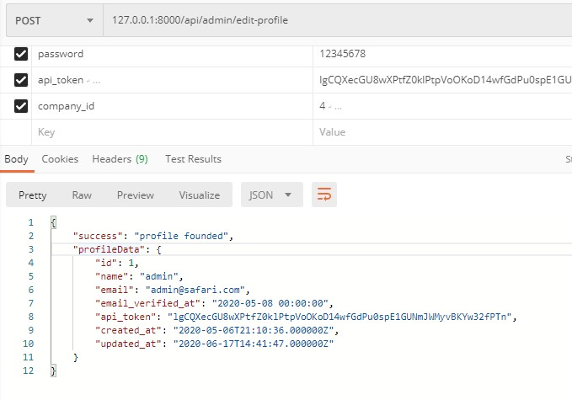

done

**Update Admin profile page**

|  |  |  |  |  |
| --- | --- | --- | --- | --- |
| **url** | **method** | **parameter** | **value** | **note** |
| /api/admin/update-profile/ | post | Api_token |  |  |
|  |  | name | Your name |  |
|  |  | current_email | Your email |  |
|  |  | phone | Your phone |  |
|  |  | new_email | New email | optional |
|  |  | current_password | Your current password |  |
|  |  | new_password | Your New password | Optional |
|  |  | new_password_confirmation |  | Required when new password set |
|  |  |  |  |  |

Done 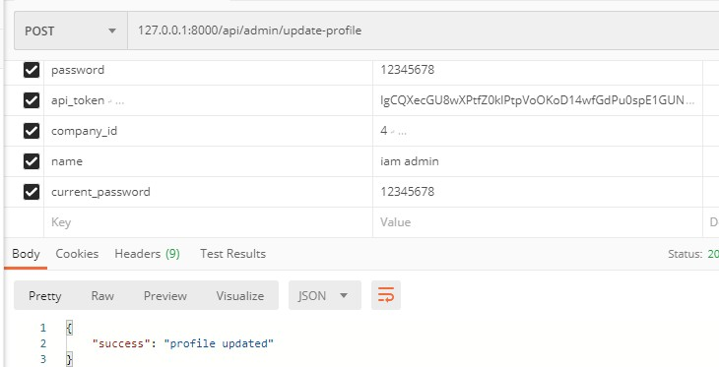

**All Ads page**

|  |  |  |  |  |
| --- | --- | --- | --- | --- |
| **url** | **method** | **parameter** | **value** | **note** |
| /api/ ads/all | post | Api_token |  |  |

done

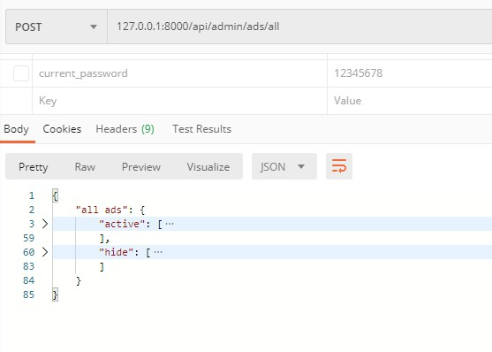

**New ads**

|  |  |  |  |  |
| --- | --- | --- | --- | --- |
| **url** | **method** | **parameter** | **value** | **note** |
| /api/ ads/new | post | api_token |  |  |
|  |  | title |  |  |
|  |  | desc |  |  |
|  |  | owner |  |  |
|  |  | img |  | One image |
|  |  | link |  | optional |

done

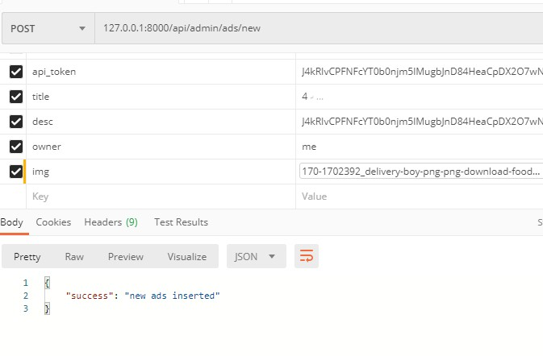

**Show or hide ads**

**Done**

|  |  |  |  |  |
| --- | --- | --- | --- | --- |
| **url** | **method** | **parameter** | **value** | **note** |
| /api/ads/control | post | Api_token |  |  |
|  |  | ads_id |  |  |
|  |  | status | show | hide | One of them |

